Chapter 4, Problem 3.

- In the circuit in Fig. 4.71, calculate v_{o} and I_{o} when v_{s} = 1 V.
- Find v_{o} and i_{o} when v_{s} = 10 V.
- What are v_{o} and I_{o} when each of the 1-Ω resistors is replaced by a 10-Ω resistor and v_{s} = 10 V?

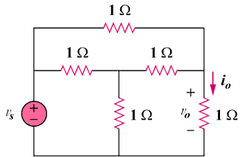

Figure 4.71
For Prob. 4.3.

